1. Pick any one app you use daily (like Zomato, Instagram, or Paytm) and write a short summary of its main features and what you think the business requirements are for that app.
Ans => Zomato – Main Features and Business Requirements
Zomato is a food delivery and restaurant discovery app. Its main features include searching for nearby restaurants, viewing menus and ratings, ordering food online, making payments, tracking deliveries, and providing reviews and ratings.
Main Features
- Restaurant search and recommendations
- Digital menus, photos, ratings, and reviews
- Online food ordering and delivery tracking
- Multiple payment options
- Offers, discounts, and subscriptions
- Customer support and order history
Business Requirements
The main business requirements of Zomato are to connect customers, restaurants, and delivery partners on one platform. The app needs to provide a simple and reliable ordering experience, process payments securely, manage restaurant and menu information, assign and track delivery partners, and handle customer feedback.

2. For the app you chose, create a test plan document that lists the testing objectives, scope, resources needed, and a rough timeline for manual testing.<br><br><em><strong>Hint:</strong> Focus on 2-3 key features such as login, search, or payment.</em>
Manual Testing Test Plan – Zomato
1. Testing Objectives
The main objectives of testing are to:
- Verify that users can successfully log in and log out.
- Ensure restaurant search provides accurate and relevant results.
- Verify that users can complete payments securely and receive the correct order confirmation.
- Identify functional, usability, and UI issues before release.
- Ensure the application works reliably across common devices and network conditions.
2. Testing Scope
In Scope
Feature 1: Login
- Valid and invalid login credentials
- OTP/password validation
- Error messages
- Logout functionality
- Basic UI and usability
Feature 2: Restaurant Search
- Search by restaurant or food item
- Filters such as location, rating, and price
- Search results accuracy
- Restaurant details and menu display
- Handling of no-result searches
Feature 3: Payment
- Successful payment
- Failed or cancelled payment
- Different payment methods
- Order confirmation after payment
- Prevention of duplicate orders/payments
Out of Scope
- Backend/server performance testing
- Security penetration testing
- Automated testing
- Detailed testing of restaurant and delivery-partner applications
3. Resources Needed
People
- 1 Manual QA Tester
- 1 Developer for defect clarification and fixes
- 1 Product/Business representative for requirement clarification
Hardware and Software
- Android and iOS smartphones
- Different screen sizes and operating-system versions
- Stable and slow internet connections for basic network testing
- Zomato test/staging environment
- Test accounts and suitable test payment methods
- Bug-tracking tool such as Jira
4. Rough Timeline
Activity | Duration
Test planning and test-case preparation | 1 day
Login testing | 1 day
Restaurant search testing | 2 days
Payment testing | 2 days
Bug reporting and retesting | 2 days
Regression testing and final report | 1 day
Total | 9 working days
5. Expected Deliverables
- Test plan document
- Manual test cases/checklists
- Defect reports with screenshots and reproduction steps
- Test execution report
- Final testing summary with pass/fail status and known issues
6. Exit Criteria
Testing can be considered complete when all planned test cases have been executed, critical and high-severity defects are resolved or accepted, and the major login, search, and payment workflows are functioning correctly.

3. Write 5 test scenarios and 8 detailed test cases (with steps, expected results, and test data) for a core feature of your selected app, such as placing a food order, sending a message, or making a payment.
Ans=> Test Scenarios
- Verify that a user can successfully place a food order.
- Verify that the user can add, update, and remove items from the cart.
- Verify that the user can apply a valid coupon or discount.
- Verify that payment succeeds and the order confirmation is generated.
- Verify that the order is handled correctly when payment fails or is cancelled.
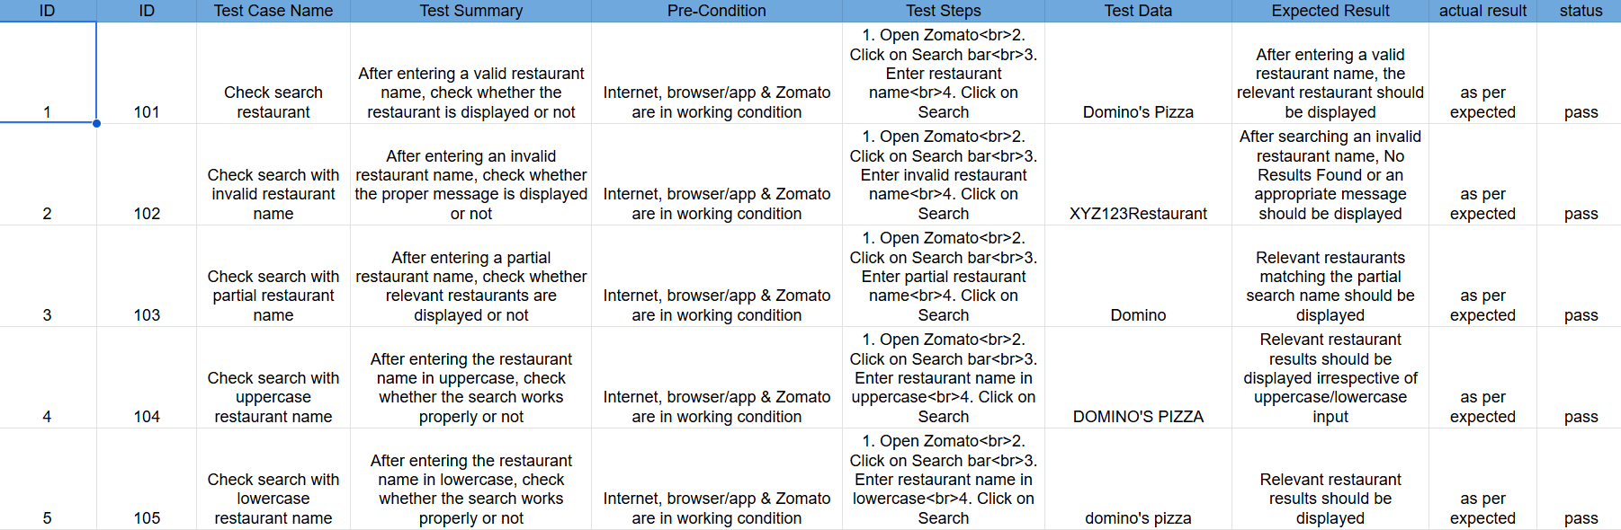
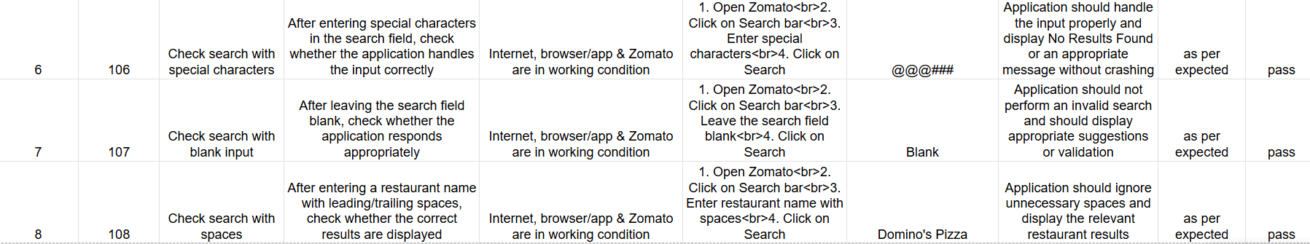

4. Create a simple Requirement Traceability Matrix (RTM) mapping at least 3 requirements from your app to the test cases you wrote.<br><br><em><strong>Hint:</strong> Use a table format: Requirement ID, Description, Test Case IDs.</em>
Ans=> Requirement ID Description Test Case IDs
REQ-101 User should be able to search for a restaurant using a valid restaurant name. TC-1, TC-3, TC-4, TC-5, TC-8
REQ-102 System should handle invalid or unsupported restaurant names and display an appropriate message. TC-2, TC-6
REQ-103 Search should support different input formats such as uppercase, lowercase, partial names, and spaces. TC-3, TC-4, TC-5, TC-8
REQ-104 System should handle blank or special-character search input without crashing. TC-6, TC-7

5. Imagine you executed your test cases and found 2 bugs. Write defect reports for both, including steps to reproduce, expected vs actual results, and severity. Then, prepare a brief final test report summarizing your testing process and results.
Ans=> Defect Reports – Zomato Restaurant Search
Defect 1
Field | Details
Defect ID | BUG-001
Functionality ID | 102
Test Case ID | TC-2
Defect Title | Incorrect message displayed for invalid restaurant search
Severity | Medium
Priority | Medium
Test Data | XYZ123Restaurant
Steps to Reproduce
- Open Zomato.
- Click on the Search bar.
- Enter XYZ123Restaurant.
- Click on Search.
Expected Result
The application should display "No Results Found" or another clear message indicating that no matching restaurant was found.
Actual Result
The application displays a blank search-results page without any message indicating that no results were found.
Status
Open

Defect 2
Field | Details
Defect ID | BUG-002
Functionality ID | 103
Test Case ID | TC-3
Defect Title | Partial restaurant name search does not display relevant results
Severity | High
Priority | High
Test Data | Domino
Steps to Reproduce
- Open Zomato.
- Click on the Search bar.
- Enter Domino.
- Click on Search.
Expected Result
The application should display restaurants whose names match the partial search term, such as Domino's Pizza.
Actual Result
The application displays No Results Found, even though a restaurant matching the partial name exists.
Status
Open

